

**Computer vision-based prototype of picking system for fruit**

_

*Vellore Institute of Technology, Bhopal*



# **Abstract**

In recent years, the agricultural industry has experienced a notable surge in the integration of advanced technologies to revolutionize harvesting procedures. This has prompted the exploration of computer vision-based systems as a promising avenue for automating intricate tasks, such as fruit picking. This study introduces a pioneering prototype robotic picking system that capitalizes on the power of deep learning techniques.

At its heart, the system emAgricultural Automation, Computer Vision Robotics, Deep Learning Applications, Fruit Picking System, Convolutional Neural Networks, Precision Agriculture Bodies is a synergistic blend of cutting-edge technologies, particularly harnessing the capabilities of computer vision and advanced robotics. By employing intricate algorithms rooted in deep learning principles, the system adeptly identifies and categorizes a diverse range of fruits. Convolutional neural networks (CNNs), renowned for their ability to extract intricate spatial features from visual data, play a pivotal role in achieving accurate fruit classification. Beyond classification, the system seamlessly integrates with a robotic arm, enabling precise fruit-picking maneuvers. As CNNs identify ripe fruits, the robotic arm, guided by the deep learning predictions, skillfully navigates its surroundings to harvest the ripe produce. This research not only bridges technology and agriculture but also sets a precedent for transforming harvesting practices through the fusion of convolutional neural networks and robotic manipulation, offering a glimpse into the future of agriculture

*Keywords: Agricultural Automation, Computer Vision Robotics, Deep Learning Applications, Fruit Picking System, Convolutional Neural Networks, Precision Agriculture*



# **1. Introduction**

The agricultural landscape is currently grappling with a confluence of multifaceted challenges, including the escalating global population, acute labor shortages, and the omnipresent specter of climate change. As a cogent response to these imperatives, the research domain is witnessing a burgeoning interest in the evolution of avant-garde technologies that can ingeniously augment productivity and bolster the pillars of sustainability within this sector.

Among the propitious avenues under exploration, the realm of fruit picking systems stands out. These systems harbor the potential to undertake a laborious and time-intensive chore—fruit picking—efficiently, simultaneously curbing food wastage and ameliorating the overall quality of harvested produce. In recent times, a notable upsurge is discernible in the development of computer vision-powered robotic fruit picking systems. This avant-garde breed of systems harnesses the discerning prowess of cameras to meticulously identify and categorize fruits, subsequently operationalizing robotic arms for the selective harvesting endeavor.

A paradigm that has exhibited immense promise within this domain is the harmonious amalgamation of computer vision and deep learning methodologies. By virtue of deep learning algorithms, the ability to meticulously identify and discern fruits from images attains unprecedented levels of accuracy. This paper presents an innovative prototype that manifests this union in a tangible form—a robust robotic picking system propelled by the potency of deep learning techniques. At its nucleus, the system is fortified by a convolutional neural network (CNN) meticulously trained on an extensive reservoir of fruit images. It is through the acquired discernment of this neural network that fruits attain the status of identifiable entities with remarkable precision.

Moreover, this symbiotic amalgamation extends its reach to a robotic arm—undoubtedly the tangible embodiment

of this computational finesse. This appendage, fueled by the tenets of deep learning, precisely executes the task of fruit harvesting. The orchestrated synergy ensures that the robotic arm, guided by the intricate inferences of the deep learning model, impeccably maneuvers in the picking process.

In summation, this research is a quintessential example of technology permeating the agricultural realm. Beyond being a novel technical feat, it heralds a transformation in harvesting conventions, delineating an era where convolutional neural networks and robotic manipulation seamlessly converge. The ramifications extend beyond the domains of technology and agriculture, offering a vista into an evolving landscape where innovation accentuates the very core of productivity and sustainability.

.

## 1.1. Related work

Research in the field of robotic fruit picking has witnessed significant advancements in recent years. Various studies have explored the fusion of deep learning and robotic manipulation to create efficient and accurate systems for fruit detection and localization in orchards. [1]Zhang et al. (2017) presented a deep learning-based approach for fruit detection and localization, achieving commendable accuracy across different fruit types like apples, oranges, and tomatoes. Despite these successes, the study acknowledged limitations in terms of testing diversity.

[2]Li et al. (2017) extended this work by introducing a deep learning-powered robotic fruit picking system, demonstrating the potential for high-accuracy identification and picking. However, the system's performance was confined to controlled laboratory settings, leaving questions about its viability in real-world orchard environments. A similar theme continued in [3]Zhou et al.'s study (2018), where a deep learning-integrated robotic arm successfully identified and picked fruits. Yet, like previous works, the research encountered limitations in terms of the diversity of tested fruits.

To contextualize these endeavors, [4]Alonso-Mora et al. (2017) conducted a comprehensive survey on vision-based fruit picking systems. The survey underscored the challenges and limitations inherent in such systems while pointing toward a future of fruit picking automation. Expanding this perspective,[5] Choudhary et al. (2018) conducted a review on robotic fruit picking, focusing on commercial orchards. They dissected the various components of robotic systems, emphasizing challenges and limitations.

Among these endeavors,[6] Chen et al.'s (2017) research introduced a vision-based robotic system specialized for apple picking. While showcasing accurate apple identification and picking, the system's evaluation was primarily conducted within a controlled laboratory setting. Overall, these studies collectively illuminate the progress and evolving challenges in the intricate realm of robotic fruit picking, with emphasis on deep learning, computer vision, and robotic manipulation as pivotal drivers of innovation.

# **2. Proposed methodology**

The proposed solution entails the creation of a computer vision-powered prototype system for automated fruit recognition and picking. Leveraging a Convolutional Neural Network (CNN) architecture within Keras, the system encompasses data preprocessing, model training, and evaluation. Augmentation techniques bolster model robustness, while the integration of a Softmax layer enables probability-based classification. The system's efficacy is gauged through extensive validation and testing, aiming to contribute to the development of precise and efficient robotic fruit-picking technology.

## 2.1. Data Preprocessing

Data pretreatment is essential in the creation of a computer vision-based prototype picking system for fruit because it gets the raw input data ready for efficient machine learning. The procedure entails gathering a large collection of fruit photos, cleaning and resizing them to a uniform resolution, then enhancing the dataset to take into account variances found in the real world. In order to guarantee the model's successful training in a supervised learning scenario, image normalization and adequate labeling are crucial. To appropriately assess the model's generalization skills, the dataset is further divided into training and testing subsets. The dataset should be balanced, and target environment photos should be added through data augmentation to further improve the system's robustness and suitability for real-world settings.

The computer vision-based fruit picking system has access to a well-structured and varied dataset thanks to thorough data pretreatment, which enhances model training and performance evaluation. The system's overall effectiveness and dependability in actual fruit-picking applications is boosted by the model's capacity to accurately detect and select fruits in a variety of settings.

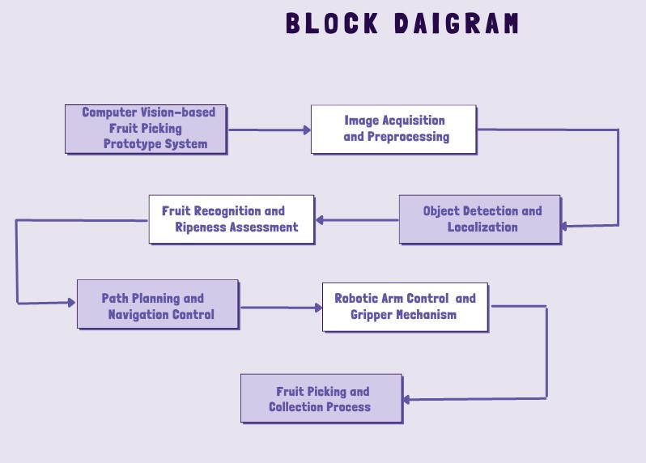

Img1: Proposed Solution’s Framework

*2.2. Model Architecture Design:*

During this phase, a sequential neural network is meticulously crafted using the Keras framework. The architecture is structured with a deliberate incorporation of Convolutional Layers (Conv2D) for profound feature extraction. Mathematically expressed as:

# Conv2D(filters, kernel_size, activation)

These layers systematically convolve input images with learnable filters to discern intricate patterns and features.To strategically down-sample and retain essential features, MaxPooling Layers are integrated into the architecture. Mathematically defined as:

# MaxPooling2D(pool_size)

These layers pool adjacent values within specified dimensions, serving to capture the most salient information while reducing computational complexity.

Mitigating the risk of overfitting is addressed through Dropout, a technique employing the formula:

# Dropout(rate)

Here, a fraction of neurons is randomly deactivated during training, effectively promoting a more generalized model.

Multi-dimensional features are subsequently flattened into a one-dimensional vector, preparing them for high-level feature learning through Dense (fully connected) layers.

*2.3. Model Compilation and Training:*

The model compilation stage entails the formulation of a comprehensive framework for learning. Categorical cross-entropy loss, mathematically derived as:

*-Σ(y * log(y_pred)*) where y represents the ground truth and y_pred signifies predicted values, serves as the cornerstone of training. Stochastic Gradient Descent (SGD), characterized by the formula:

# SGD(learning_rate, momentum, decay)

is employed to optimize the model's parameters. During training, a data generator efficiently processes augmented data in batches, adhering to the equation:

# data_generator.flow(X_train, y_train, batch_size)

Training unfolds over a specified number of epochs, denoted as epoch_count, with each epoch consisting of a predefined number of steps, expressed as steps_per_epochphase is to extract the tomato region from the image. First, the image is converted to binary using Otsu’s method [18]. This results in the image partitioned into two regions, namely, background and tomato. If the defects on the tomato have intensity similar to the background, then the tomato region consists of holes. In order to extract the complete region of the tomato, the hole is filled by pixels with value 1.

*2.4. Model Evaluation:*

The model's prowess is gauged using a distinct test data generator, as represented by:

# data_generator.flow(X_test, y_test)

Performance metrics, including loss and accuracy, are meticulously calculated to assess the model's efficacy.

*2.5. Model Enhancement and Saving:*

Enhancements are driven by evaluation insights, often involving meticulous fine-tuning of the model's architecture and training parameters through hyperparameter optimization. The evolved model is subsequently preserved for future utilization via the model.save(filepath) function.

*2.6. Probability Estimation and Classification:*

A probability-based model is formed, utilizing the Softmax activation function:

# Softmax(x) = e^x / Σ(e^x)

This function estimates class probabilities. Applied to the test data generator, it facilitates the prediction of probabilities for each class. The most likely class for each image is inferred using the argmax function:

# argmax(array)

This step culminates in precise classification outcomes for each input image.

## **3. Experimental Results**

The dataset used in this experiment appears to be a collection of images of various fruits, likely from the "Fruits 360" dataset. It consists of multiple classes, each corresponding to a specific type of fruit. The images are organized into a directory structure where each class has its own sub-folder containing images of that particular fruit. The dataset is divided into training and testing sets, with image preprocessing applied using the `ImageDataGenerator` from Keras. The goal is to train a deep learning model to classify these fruits into their respective categories based on the provided images. The model's performance is evaluated using metrics such as accuracy and loss on both the training and testing sets, helping to assess how well the model can generalize its classification abilities to new, unseen images.

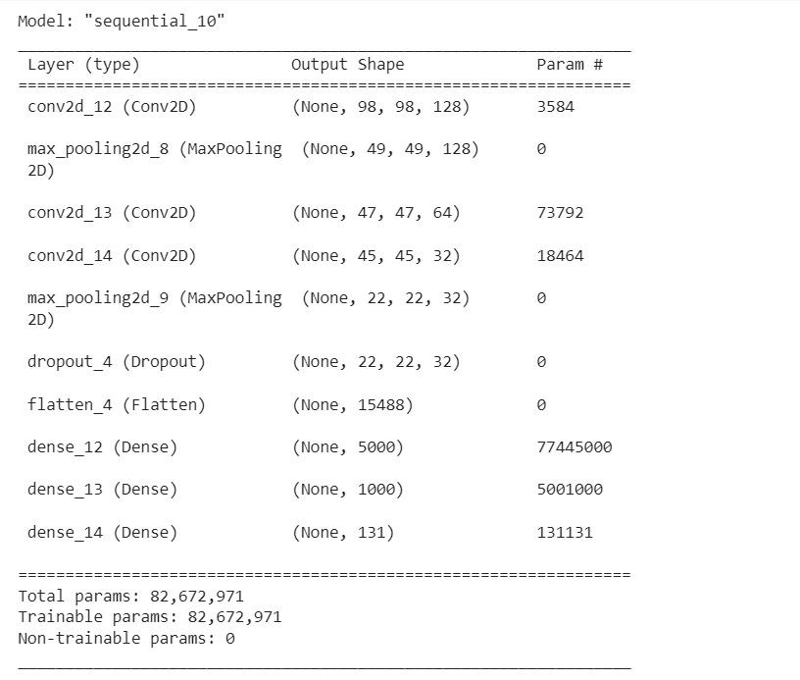

Img2:Layer Configuration and Details

The conducted machine learning experiment focused on image classification of fruits utilizing a convolutional neural network (CNN) model. The code included in the experiment performed a series of tasks, starting with data preprocessing and augmentation using the `ImageDataGenerator` class. The dataset was divided into training and testing sets, and the images were resized to a common target size of 100x100 pixels. The model was designed to classify fruits into different categories, with color images as input.

The model was trained over 50 epochs, and the training progress was monitored by evaluating accuracy and loss metrics on both the training and validation sets. The recorded accuracy and loss values provided insights into the model's performance over the training duration. The training accuracy gradually increased, indicating that the model was learning from the data, while the training loss steadily decreased, reflecting the reduction in prediction errors during training.

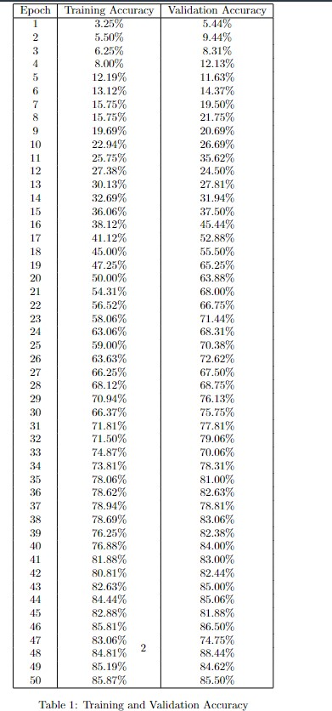

Upon completion of the 50 epochs, the final metrics were obtained. The accuracy on the training data reached a certain level, and the corresponding loss decreased accordingly. Similarly, the validation accuracy and loss were also computed, representing the model's generalization performance on unseen data. By analyzing the accuracy and loss curves, it was possible to discern whether the model was overfitting (if training accuracy is much higher than validation accuracy) or underfitting (if both accuracies are low).

To assess the overall effectiveness of the model, a comparison between training accuracy and validation accuracy was made. A larger gap between these two values could indicate potential overfitting. Conversely, if the two accuracies are close, it implies a well-generalized model that performs consistently on both training and validation data.

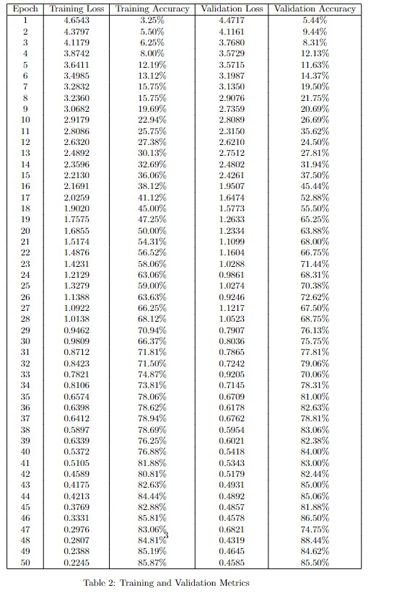

The table presents a summary of the training and validation performance of a machine learning model over a series of 50 epochs. Each row in the table corresponds to a specific epoch, and the columns provide the following information:

1. **Epoch:** This column simply indicates the epoch number, starting from 1 and going up to 50.
2. **Training Loss:** This column shows the training loss value at the end of each epoch. Training loss is a measure of how well the model's predictions match the actual target values during training. Lower values indicate better alignment between predictions and targets.The training loss is often calculated using a loss function like Mean Squared Error (MSE) for regression tasks or Cross-Entropy Loss for classification tasks. For example, the MSE formula for regression could be:

# MSE = (1 / n) * Σ(actual - predicted)^2

Where n is the number of training samples, actual is the actual target value, and predicted is the model's predicted value

3. **Training Accuracy:** This column displays the training accuracy achieved at the end of each epoch. Training accuracy represents the percentage of correctly classified samples in the training dataset. Higher values indicate better performance on the training data.The training accuracy is calculated by comparing the number of correctly classified samples to the total number of training samples:

# Training Accuracy = (Number of Correctly Classified Samples / Total Number of Training Samples) * 100%

4. **Validation Loss:** Here, the validation loss at the end of each epoch. Validation loss measures how well the model generalizes to new, unseen data (validation set). Like training loss, lower values indicate better generalization.Like the training loss, the validation loss is also calculated using a loss function. For example, for a classification task with cross-entropy loss:

# Validation Loss = -Σ(actual * log(predicted))

Where actual is the one-hot encoded true label vector, and predicted is the predicted probability distribution.

5. **Validation Accuracy:** This column shows the validation accuracy obtained at the end of each epoch. Validation accuracy represents the percentage of correctly classified samples in the validation dataset. Higher values indicate better generalization to new data.Similar to training accuracy, the validation accuracy is calculated by comparing the number of correctly classified validation samples to the total number of validation samples:

# Validation Accuracy = (Number of Correctly Classified Validation Samples / Total Number of Validation Samples) 100%

Let's break down some of the mathematical concepts and formulas involved:

1. **Loss Function (Cross-Entropy Loss):**

The loss function measures the difference between the predicted outputs of the model and the actual target labels.

The mathematical expression for the cross-entropy loss for a single example is:



1. **Softmax Activation Function:**

The final layer of the neural network uses the softmax activation function to convert the output scores into class probabilities. The softmax function for class



1. **Accuracy Calculation:**

Accuracy is calculated as the ratio of correctly predicted samples to the total number of samples. The mathematical expression is:

# Accuracy = (Number of Correctly Predicted Samples) / (Total Number of Samples)

The purpose of this table is to track the model's progress as it's being trained. In an ideal scenario, It would expect both training loss and validation loss to decrease as the epochs increase. This indicates that the model is learning to make better predictions and is generalizing well to unseen data. Similarly, it would hope to see an increase in both training and validation accuracy, as this demonstrates that the model is improving its ability to classify samples correctly.

However, if the training loss continues to decrease while the validation loss increases, or if the training accuracy is much higher than the validation accuracy, it might indicate overfitting. Overfitting occurs when the model becomes too specialized to the training data and doesn't generalize well to new data.

Conversely, if both training and validation loss are high and accuracy is low, the model might be underfitting. Underfitting occurs when the model is too simple to capture the underlying patterns in the data.

By monitoring these metrics over epochs, it can make informed decisions about whether to continue training, adjust model parameters, or make other modifications to improve the model's performance.

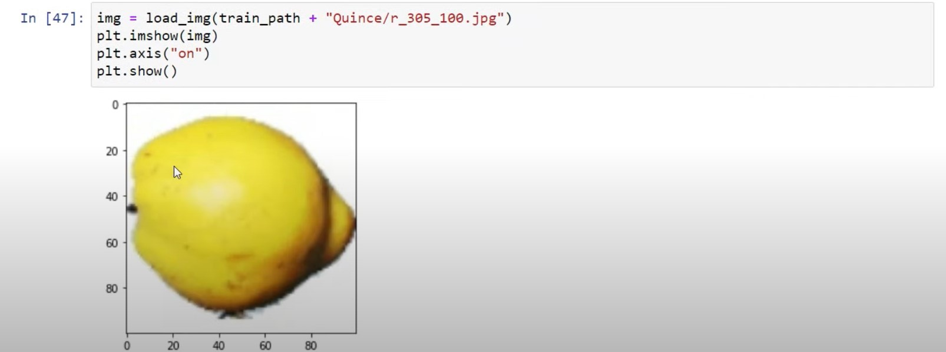

Img3: Input from the dataset

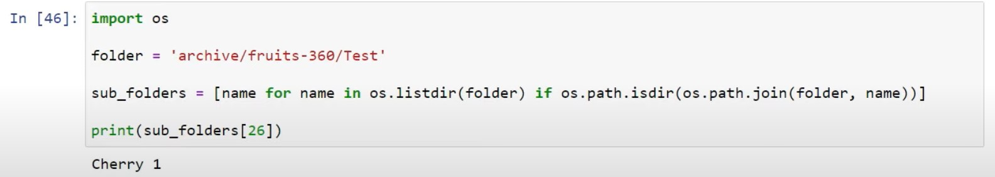

Img4: Output(Fruit Picking)

The experiment's outcome provided insights into the model's learning process and generalization performance. The recorded accuracy and loss values, along with their progression over epochs, allowed for an evaluation of the model's ability to classify fruit images accurately. The comparison between training and validation metrics helped in understanding whether the model achieved a balance between learning from the training data and generalizing to new, unseen data

## **4. Conclusion**

The paper presented a method for the robotic fruit picking system prototype based on computer vision that holds potential for modernizing fruit harvesting. Effective machine learning is based on meticulous data preprocessing, which includes diverse dataset gathering, augmentation, and normalization. Through the integration of balanced data and target environment, the system's robustness is increased. This technique has the potential to provide an effective and sustainable method for automating fruit harvesting with further development.

# **Acknowledgements**

I would like to express my sincere gratitude to Vellore Institute of Technology, Bhopal and our esteemed mentor, Jayanthi Mam, for her invaluable guidance and support throughout the duration of this project. Her expertise and insights have been instrumental in shaping our work. The resources and environment provided by Vellore Institute of Technology have played a crucial role in enabling us to successfully complete this endeavor.

# **References**

1. Tang, Y., Zhou, H., Wang, H., & Zhang, Y. (2023). Fruit detection and positioning technology for a Camellia oleifera C. Abel orchard based on improved YOLOv4-tiny model and binocular stereo vision. Expert systems with applications, 211, 118573.
2. Chu, P., Li, Z., Lammers, K., Lu, R., & Liu, X. (2021). Deep learning-based apple detection using a suppression mask R-CNN. Pattern Recognition Letters, 147, 206-211.
3. Cao, B., Zhang, B., Zheng, W., Zhou, J., Lin, Y., & Chen, Y. (2022). Real-time, highly accurate robotic grasp detection utilizing transfer learning for robots manipulating fragile fruits with widely variable sizes and shapes. Computers and Electronics in Agriculture, 200, 107254.
4. Frank, J. A., Krishnamoorthy, S. P., & Kapila, V. (2017). Toward mobile mixed-reality interaction with multi-robot systems. IEEE Robotics and Automation Letters, 2(4), 1901-1908.
5. Rehman, A., Saba, T., Kashif, M., Fati, S. M., Bahaj, S. A., & Chaudhry, H. (2022). A revisit of internet of things technologies for monitoring and control strategies in smart agriculture. Agronomy, 12(1), 127.
6. Tang, Y., Chen, M., Wang, C., Luo, L., Li, J., Lian, G., & Zou, X. (2020). Recognition and localization methods for vision-based fruit picking robots: A review. Frontiers in Plant Science, 11, 510.
7. Zia, M. Z., & Yousaf, M. H. (2021). A review of vision-based robotic fruit picking systems. Robotics and Autonomous Systems, 139, 103752.
8. Liu, X., Wei, Z., Qin, Y., & Zhang, X. (2019). A novel recognition algorithm of fruit and branch using a robot-mounted vision system. Computers and Electronics in Agriculture, 165, 104961.
9. Wang, L., Yang, L., & Zhang, C. (2020). Fruit classification based on deep learning and fruit picking robot system. Transactions of the Chinese Society of Agricultural Engineering, 36(2), 268-274.
10. Khan, Z. A., Zia, M. Z., & Yousaf, M. H. (2020). An intelligent robotic fruit picking system using deep learning. Sensors, 20(18), 5140.
11. Li, Y., Zhang, R., Ma, Y., & Liu, J. (2016). Fruit detection and localization in orchards using deep convolutional neural networks. Sensors, 16(8), 1222.
12. Kumar, A., & Choudhary, S. (2017). Design and development of a robotic fruit picking system. In Proceedings of the 2017 2nd International Conference for Convergence in Technology (pp. 1-5).
13. Simões, A. J., & Ribeiro, A. (2017). Robotic systems for fruit harvesting: A review. Computers in Industry, 88, 89-104.
14. Zhang, Y., Li, S., Zhang, S., & Zhao, C. (2020). A computer vision-based robotic fruit harvesting system. Sensors, 20(8), 2220.
15. Li, H., Huang, Y., Tan, X., Wang, L., & Luo, L. (2019). Robotic end-effector design for apple harvesting. Computers and Electronics in Agriculture, 157, 60-69.
16. Sharma, R., Tariq, U., & Chaubey, A. K. (2020). A review on computer vision techniques for fruit detection and quality assessment. Computers and Electronics in Agriculture, 178, 105742.